PVCS Check In/Check Out Instruction

PVCS operation Guide 1
I. Select Workset 1
II. Create New Item 3
1. Use Command line 3
2. Use PVCS UI 5
III. Check out item 7
1. For single item check out 7
2. For multiple items check out 9
IV. Undo check out 11
VI. Check in item 13

I. Select Workset
Steps:
  - Logon to Dimensions (PVCS);
  - Select menu Workset→Change
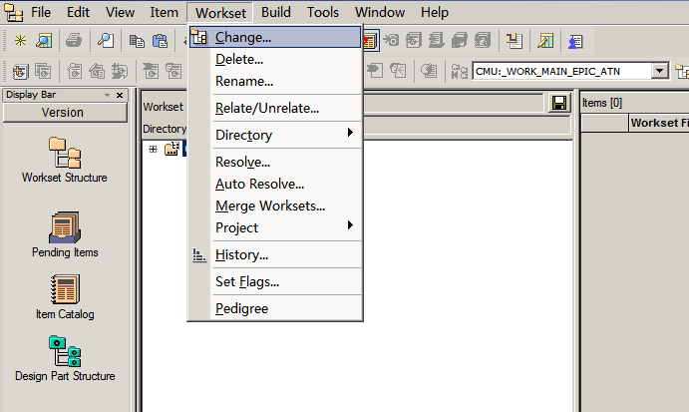
  - Select Product and Workset

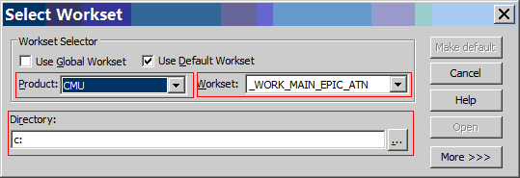
Product: CMU
Workset: CMU:_WORK_MAIN_EPIC_ATN
Directory: local working directory
  - Click “Make default” in the up dialog
It will need not to select WorkSet next time you logon to PVCS after click “Make default”.

II. Create New Item

After select correct Workset, you can run script to put new item into PVCS.

1. Use Command line
Steps:
  - Select proper WorkSet
  - Select Menu File→Run
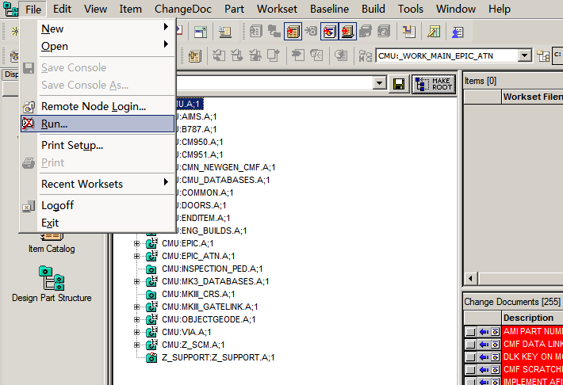

3. Use Browse to select Cmd file Or simply type in commands:
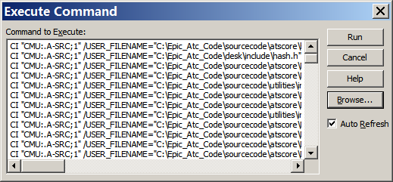

4. click run to add item.

A Sample Command:
[
CI "CMU:.A-SRC;1"
/USER_FILENAME="C:\Epic_Atc_Code\sourcecode\atscore\build.bat"
/FILENAME="build-10.bat"
/PART="CMU:EPIC_ATC_ATSCORE.A;1"
/WS_FILENAME="Epic_Atc_Code\sourcecode\atscore\build.bat"
/DESCRIPTION="EPIC ATC file"
/FORMAT="BAT"
/COMMENT="initial development"
/CHANGE_DOC=(CMU_CR_10249)
KEEP
]
Command between [ and ] must be in one line when running.

USER_FILENAME: full path name of local file to be put into PVCS
FILENAME : internal file name of PVCS
PART : PART name
WS_FILENAME : relative path name of file for PVCS
DESCRIPTION : file description
FORMAT: file extension, not always BAT, it depends on the file you create.
COMMENT: operation comment
CHANGE_DOC: related CR name
KEEP: keep local file when successfully check in new item.
If no Keep in command, it will remove file when check in the new item.

2. Use PVCS UI
Steps:
- Select proper WorkSet
- Select PART name where you want to add new item.
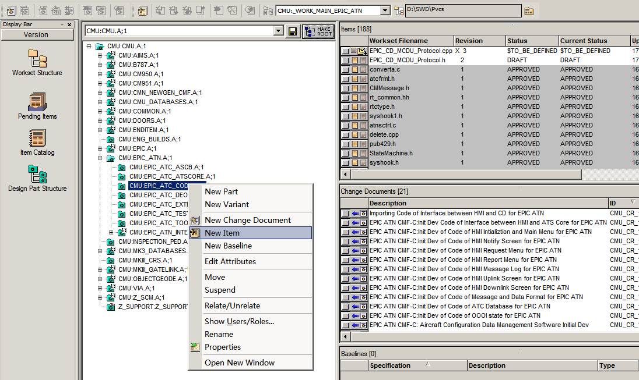
3. Fill in the New item dialog:
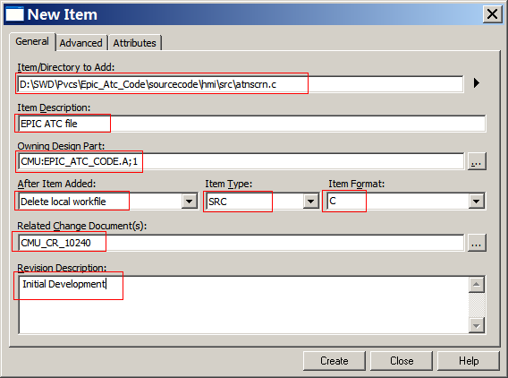
Item/Directory to Add: local path name of file to add.
Item Description: EPIC ATC file
Owning Design Part: the Design part you will add new item into.
After Item Added: delete or keep local file when the file put into PVCS.
Item Type: file type
Item Format: automatically detected file extension.

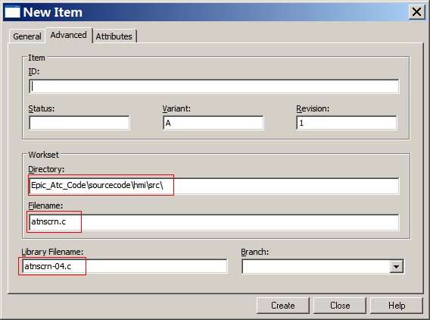
Directory: relative path for PVCS to store file. It will show in Workset structure.
Filename: local filename.
Library Filename: internal name for PVCS to store file.

III. Check out item

1. For single item check out
Steps:
- select Design Part Structure.
- select file need to do check out.
- Right click on file, select “Check Out”

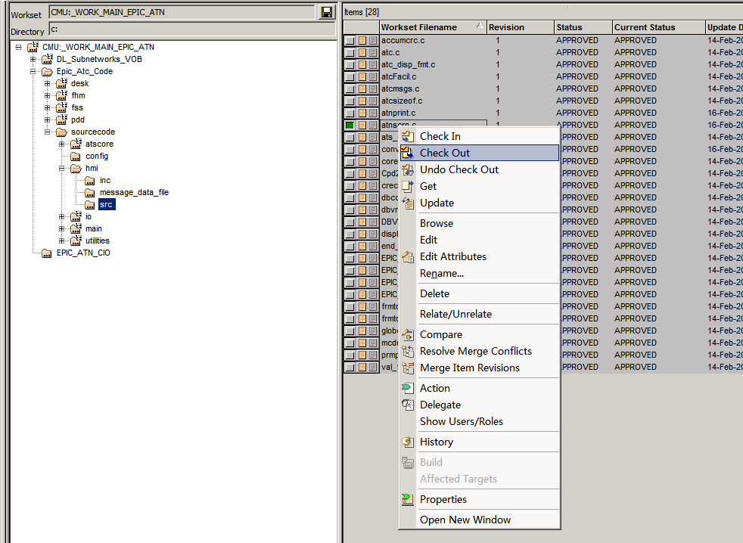

d. fill in check out dialog
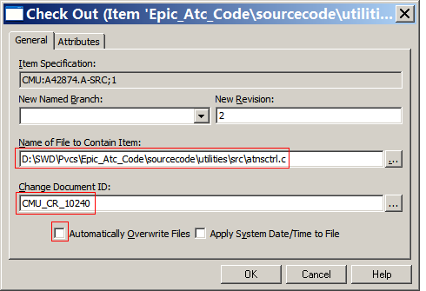
Name of File to Contain Item: local file path name to contain check out file
Change Document ID: related CR for this check out.
Automatically Overwrite Files: overwrite local file or not when check out.

2. For multiple items check out
Steps:
a. select Design Part Structure.
b. Hold Ctrl , then to select multiple items need to do check out.
c. Right click on files, select “Check Out”
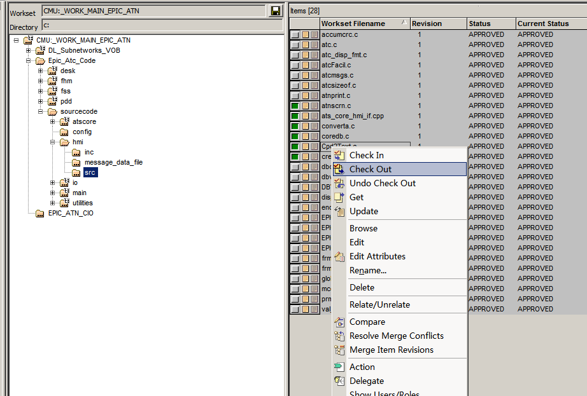

d. fill in check out multiple items
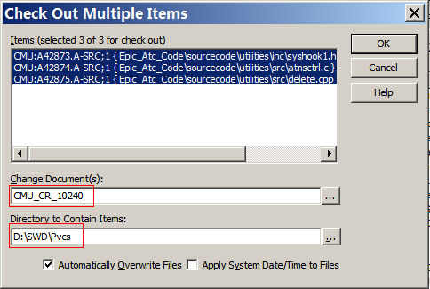

Change Document ID: related CR for this check out.
Director to Contain Item: Root directory to contain check out items.
Automatically Overwrite Files: overwrite local file or not when check out.

IV. Undo check out
Steps:
1. Select WorkSet
2. Find the item need to undo check out
3. right click on the item, select “Undo check out”
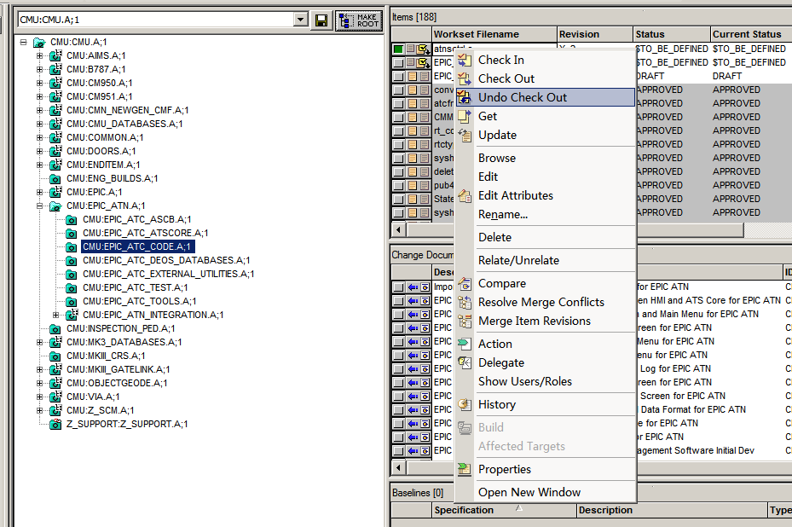
4. Click ok
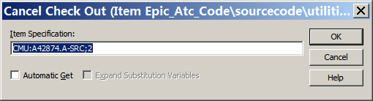

VI. Check in item
Steps:
1. Find item need to Check in
2. Right click on item , select “Check In”
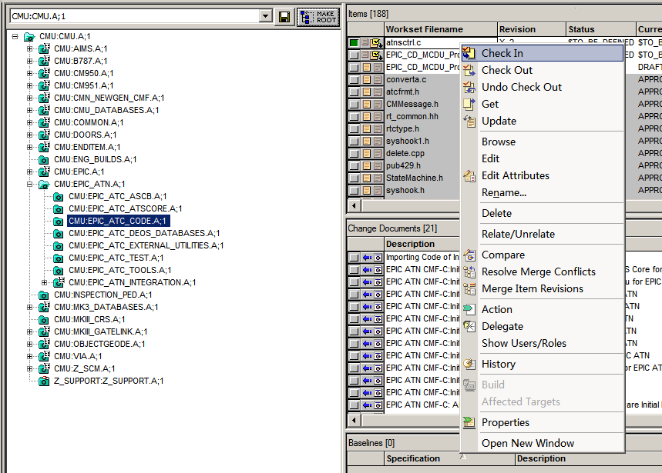
3. Fill in check in dialog
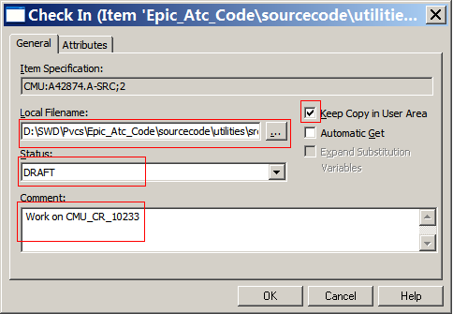
Local Filename: local file to be check in
Status: New status for the item after check in, normally select DRAFT
Comment: comment on the check in, it’s mandatory.
Keep Copy in User Area: keep the local file after check in, or it will remove it.
Automatic Get: Get a fresh copy from PVCS after check in.

